**UNIT 7: MY NEIGHBORHOOD**

**I/ Warm up**

**Task 1: Matching**

**1. be**

**2. go**

**3. eat**

**4. live**

**5. attend**

**6. see**

**7. do**

**8. write**

**9. work**

**10. collect**

1. **gone**
2. **lived**
3. **attended**
4. **been**
5. **eaten**

f. **collected**

1. **seen**
2. **done**
3. **written**
4. **worked**

**Task 2: Choose the correct answer**

**A.**

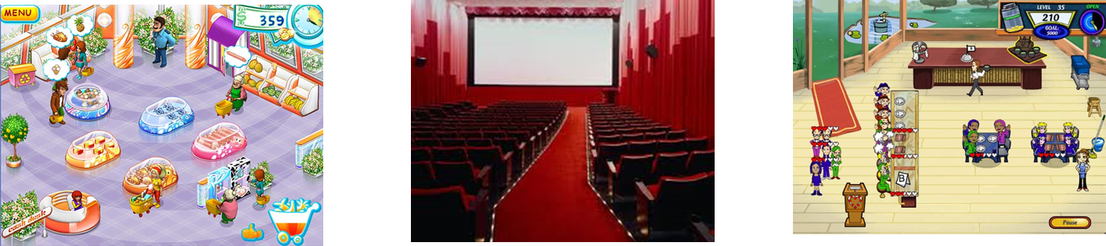

1. **Supermarket B. movie theater C. restaurant**
2. We can see a movie at a …………
3. We can see a movie at a …………
4. Children can play at a…………
5. We can buy everything at a…………

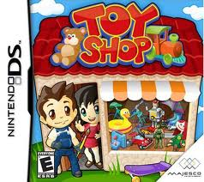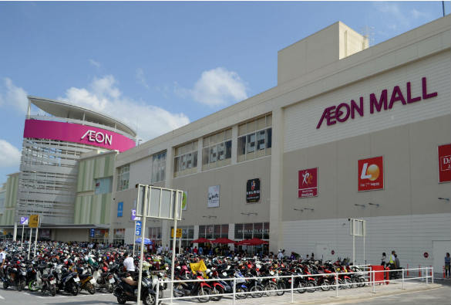

**B.**

* We can buy food, books; you can eat, drink, see a movie or play game at a ……..

**II. VOCABULARY**

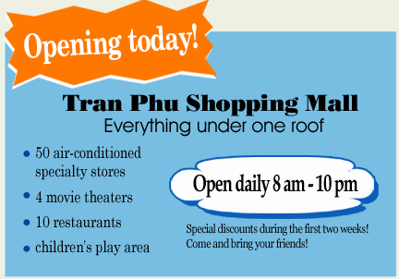**III/ Read**

A new shopping mall is opening in Nam’s neighborhood today. It is very different from the present shopping area. All the shops are under one roof. That will be very convenient, especially during the hot and humid summer months. Customers will shop in comfort and won’t notice the weather.

Some people in the neighborhood, however, are not happy about the changes. The owners of the small stores on Tran Phu Street think the mall will take their business. Some of the goods in the new stores will be the same as the ones in the small shops, but the stores in the mall will offer a wider selection of products, some at cheaper prices.

The residents and store owners have been concerned about the new mall for a few months. They have organized a community meeting in order to discuss the situation.

**II. PRACTICE**

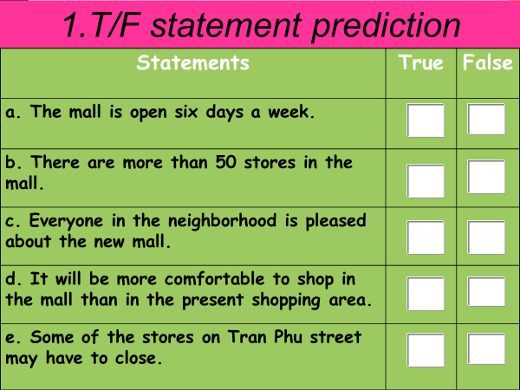

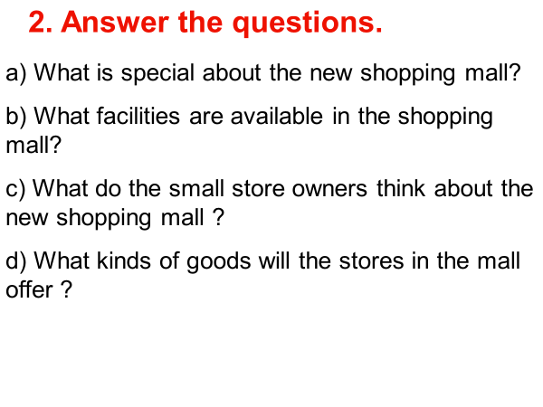

**ANSWER KEY**

|  |  |  |
| --- | --- | --- |
| STATEMENT | **T** | **F** |
| a. The mall is open six days a week.  ⟶ The mall is open seven days a week. |  | **✓** |
| b. There are more than 50 stores in the mall.  ⟶ There are 50 stores in the mall. |  | **✓** |
| c. Everyone in the neighborhood is pleased about the new mall.  ⟶ Not everyone is pleased with the mall. |  | **✓** |
| d. It will be more comfortable to shop in the mall than in the present shopping area. | **✓** |  |
| e. Some of the stores on Tran Phu Street may have to close. | **✓** |  |

**2. ANSWER THE QUESTION**

a. All the shops are under one roof.

b. The facilities such as air-conditioners, movie theatres, restaurants and children’s play areas are available in the shopping mall.

c. They think that the new shopping mall will take their business.

d. The stores in the mall offer a wider selection of products, some of which are sold at cheaper prices.

**III. Homework**

1. Learn new words by heart
2. Prepare for the next lesson: Write